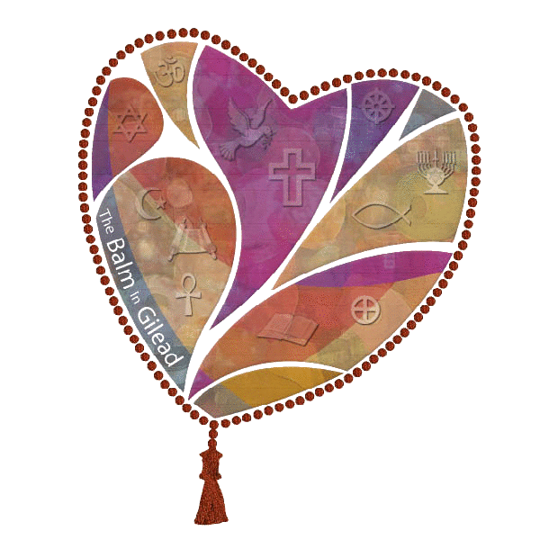
Black Church
Week Of
Prayer
For the
Healing
Of AIDS
March 6 - 13, 2021

The Black Church of Prayer for the Healing of AIDS is modeled after the successful, innovative Harlem Week of Prayer for the Healing of AIDS which was established in 1989 by The Balm of Gilead in New York City. The Week of Prayer was designed as a bold act of community outreach to Harlem’s religious leaders to address the community’s devastation by HIV/AIDS.
From March 1 - 7, 2021 over 10,000 black churches across the U.S. will use the power of the black pulpit to educate their communities about HIV/AIDS and to heal hearts and minds of denial, silence, and stigma that continues to block effective interventions for the prevention, treatment and testing of HIV in the black community. The black church continues to be the cornerstone of African American life. Given this, and considering the proliferation of HIV in black communities it is essential that religious organizations lead the struggle to stop the seemingly uncontrollable spread of the disease and deliver and demand more services and resources for people and families infected or affected
Due to the Covid-19 epidemic we will not be conducting in person events. But we still want to commemorate this time-frame. We are asking that your church/Ministry would pray for people and families infected or affected by HIV. Please contact Jim Addison of the Black Health Coalition of WI, Inc. at (414)933-0064 or jaddison@bhcw.org to receive a participation form or other educational materials to be distributed during the month of March.

WI HIV Program Division of Public Health

